G-R2040Z
Double Column Machining Center
(Semi-protective sheet metal)
Technology Agreement
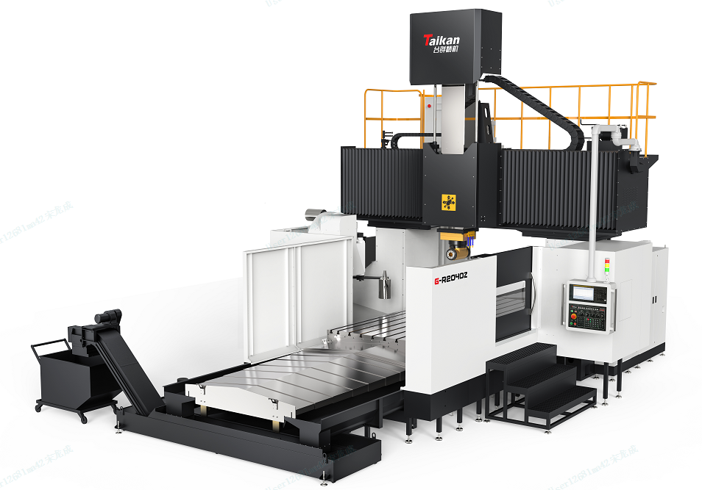
（Just for a reference）

Ⅰ.Equipment technical description, parameters and configuration

1. Equipment technical description
G-R2040Z double column machining center is mainly used to process small and medium-sized complex parts of ferrous and non-ferrous metals. It has the characteristics of high speed, high precision, high flexibility and environmental protection. Its performance indicators and accuracy indicators fully comply with national standards. The products are modularly designed and can be serialized and customized according to market demand. Its good performance-price is the best choice for domestic and foreign customers.
The quality of the processed and assembled finished products of all machine tool parts complies with the product drawings and relevant technical requirements. Its safety standards comply with the relevant provisions of GB15760-2004 "General Technical Conditions for Safety Protection of Metal Cutting Machine Tools", and its accuracy standards comply with GB/T17421-2000 "Machine Tool Inspection" General Principles" and the relevant provisions of GB/T 25658.1-2010 "CNC Fixed Beam Gantry Boring and Milling Machine".
- Basic Machine：The machine tool adopts a fixed gantry frame and a movable worktable structure. The basic large parts are made of high-quality resin sand molding and high-strength cast iron materials to ensure high rigidity and stable accuracy of the machine tool. The main castings have undergone finite element analysis, and the ribs are reasonably arranged to fully meet the needs of high-torque cutting of machine tools.
- Spindle：The machine tool comes standard with a high-rigidity mechanical spindle directly connected to a variable speed gearbox. It has large low-speed torque, high-speed and high-precision, low noise and easy maintenance, and can meet the requirements of boring, milling and drilling. The standard water cooler cools the spindle, extends the service life of the spindle, and reduces the impact of spindle thermal deformation on machining accuracy.
- Automatic right angle milling head and tool magazine：The machine tool comes standard with an automatic right-angle milling head and milling head magazine, which can realize automatic exchange of milling heads and protective covers. The workpiece can be clamped at one time, enabling pentahedral processing.
- Guideways：X 、Y 、 Z three axis all adopt imported heavy-duty roller linear guides, which have low friction, strong load-bearing capacity, small high-speed vibration, no crawling at low speed, and high positioning accuracy. The crossbeam guide rail adopts a stepped arrangement to increase the guide rail span and improve the load-bearing capacity. It has good load-bearing performance and ensures stable cutting during processing.
- Drive：The three feed axes of X, Y and Z are all driven by FANUC feed motors, which have good stability and reliable operation. The X-axis and Y-axis adopt a large-lead ball screw drive structure; the Z-axis uses a motor directly connected to the ball screw, and the Z-axis uses a nitrogen balance cylinder to balance the weight of the ram.
- System：Equipped with high-performance FANUC 0i-MF Plus (1) CNC system is configured to ensure the stability of machine tool control and the CNC processing functions and auxiliary functions required by users.
- Working conditions：
- Power supply: three-phase AC 380V±10%; 50Hz±1Hz;the machine tool should have reliable grounding：copper wire ≥16mm²；resistance <4Ω.
- In order to keep the static accuracy of the machine tool within the guaranteed value range, the machine tool should be installed in an area not affected by air flow. It is necessary to keep the surrounding temperature between 17℃~25℃, the humidity between 40% and 75%, and The ambient temperature change within 24 hours should be within ±2°C, and the ambient temperature change from the ground to about 5 meters high should be maintained within 2°C.
- If the requirements for the parts being processed are not high, the ambient temperature range can be relaxed to 10°C ~ 40°C.
- Keep away from light sources, vibration sources and heat sources, and away from high-frequency generators, discharge motors, welding machines, etc. to avoid electrical interference that may cause the machine tool NC system to malfunction.
- If the voltage in the area where it is used is unstable, the machine tool should be equipped with a regulated power supply to ensure the normal operation of the machine tool.
- In order to ensure the normal operation of the equipment, if the compressed air source does not meet the cleanliness requirements, an air source purification device (dehumidification, oil removal, filtration) should be added before the air intake of the machine tool.
- In order to maintain the accuracy and stability of the machine tool, the foundation must be made strictly in accordance with the requirements of the foundation diagram provided by the company

2. Basic parameters
Item |  |  |  | Unit | Parameters | Remark
Moving range | X axis |  |  | mm | 4200
Moving range | Y axis |  |  | mm | 3200
Moving range | Z axis |  |  | mm | 1000
Moving range | Distance from spindle end face to worktable |  |  | mm | 250～1250
Moving range | Door width |  |  | mm | 2450
Worktable | Size |  |  | mm | 2000*4000
Worktable | Max load |  |  | Kg | 19000
Worktable | T-shaped slot (number of slots-slot width*spacing) |  |  | mm | 28
Spindle | Motor power (rated/max) |  |  | KW | 22/35
Spindle | Spindle speed (full gear drive) |  |  | r/min | 4000～5000(Optional center through coolant 4500) | Within 120minutes
Spindle |  |  |  | r/min | 40～4000 | Continuously
Spindle | Spindle torque (rated/Max.) |  |  | Nm | 790/1258
Spindle | Spindle diameter |  |  | mm | φ210
Spindle | Gear ratio |  |  |  | 1:1/1:5.64
Spindle | Ram section |  |  | mm | 400*400
Spindle | Spindle taper/Pull stud |  |  |  | BT50/ P50T-I（MAS403）
Spindle | Automatic right angle milling head (tool magazine) |  |  |  | BT50, automatic head change, automatic tool unclamping, automatic rotation, 5 degrees/min, 2000r/min, 600Nm, 22KW; milling head uses tool diameter ≤φ125.
Speed | Cutting feed speed range |  |  | mm/min | 8000/8000/8000
Speed | X, Y, Z axis rapid movement speed |  |  | mm/min | 10000/15000/10000
Guideways |  | X/Y/Z |  |  | 2-55/2-55/ hard rail
Ball screw |  | X/Y/Z（Diameter x Lead） |  | mm | 80x20/63x25/50x8
Precision | Position accuracy(X/Y/Z) |  |  | Without grating ruler | 0.032/0.027/0.016
Precision |  |  |  | With grating ruler | 0.028/0.023/0.014
Precision | Repeatability (X/Y/Z) |  |  | Without grating ruler | 0.020/0.017/0.010
Precision |  |  |  | With grating ruler | 0.018/0.015/0.009
Other | Z-axis counterweight |  |  |  | Oil pressure + nitrogen balance
Other | Control system |  |  |  | FANUC 0I-MF PLUS(1)/αmotor | Includes inclined surface processing function (A02B-0304-R522 and A02B-0304-J998 3D hand wheel return)
Other | Air |  | Flow | L/min | 300
Other |  |  | Air pressure | MPa | 0.6∼0.8
Other | Total power capacity |  |  | KVA | 60
Other | Cooling box volume |  |  | L | 580
Other | Machine tool appearance dimensions ） |  |  | mm | 10238*6634*5600
Other | Sheet metal protection |  |  | set | Semi-protective sheet metal | Work area protection only

3. Equipment standard configuration
No. | Item | No. | Item
1 | FANUC 0I-MF PLUS(1)/αmotor CNC system | 14 | Milling head
2 | 10.4-inch monitor | 15 | Mechanical spindle
3 | Handheld operating unit | 16 | Crossbeam guide rail protective cover
4 | Suspended operator panel | 17 | Bed guide rail protective cover
5 | Pneumatic system | 18 | Three-color signal light
6 | Air gun | 19 | Lighting device
7 | Automatic lubrication system | 20 | Electric cabinet air conditioner
8 | Spindle cooling system (water cooling) | 21 | Hydraulic station
9 | Gearbox cooling system (oil cooling) | 22 | Ram Nitrogen Balance System
10 | Workpiece cooling system | 23 | Basic installation kit
11 | Chain plate chip conveyor + chip collecting car | 24 | Technical documents
12 | Spiral chip conveyor | 25 | Operating foot pedal
13 | Automatic right angle milling head

4. Optional configuration

No. | Item | Whether to choose | Remark
1 | Sinking foundation | □ | The machine tool work surface is 100 mm above the ground; the user makes protective covers and supporting parts for the foundation earthquake trench and sinking pit.
2 | 24 disc tool magazine (Vertical tool change only) | □ | Tool magazine brand:Taikan; Maximum tool diameter (full tool/empty tool): Φ110mm/Φ200mm； Maximum tool length:350mm； Maximum tool weight:18KG， Total tool weight: ≤360KG.
3 | 40-tool chain tool magazine (Vertical tool change only) | □ | Tool magazine brand ：OKADA； Maximum tool diameter (full tool/empty tool):Φ110mm/Φ200mm； Maximum tool length:350mm； Maximum tool weight:18KG Total tool weight: ≤600KG.
4 | Grating ruler | □ | Fagor
5 | Grating ruler | □ | Heidenhain
6 | 2MPa center through coolant | □ | this option, the maximum spindle speed is 4500
7 | 3MPa center through coolant | □ | this option, the maximum spindle speed is 4500
8 | Column heightening 248 (whole column) | □ | The distance from the end face of the spindle to the table becomes 500~1500, the height of the machine tool becomes 5850, and the rigidity is reduced by 20%.
9 | Column heightening 248 (Booster pad) | □ | The distance from the end face of the spindle to the table becomes 500~1500, the height of the machine tool becomes 5850, and the rigidity is reduced by 20%.
10 | Chip removal water gun | □
11 | Fully protected sheet metal | □ | No cap
Note: If you select this configuration, please mark √ in the corresponding item box. This table only lists the main selected configurations. For other selected configuration items, please consult the manufacturer and fill in the blanks.

Ⅱ. Brands of main parts of equipment
No. | Item | Brand | Remark
1 | Control system | FANUC | Japan
2 | Spindle unit | Taikan | Made in China
3 | Automatic right angle milling head | Molisen | Made in China
3 | Ball screw | PMI/HIWIN | Taiwan
4 | Ball screw bearing | NSK | Japan
5 | Linear Guideways | PMI/HIWIN/INA | Taiwan /Germany
7 | Lubrication system | Baotn | Made in China
8 | Main pneumatic components | SMC | Japan
9 | Gearbox oil cooler | Tongfei | Made in China
10 | Spindle water cooler | Saiyang | Made in China
11 | Servo reducer (X-axis) | Stober/Alpha | Germany
12 | Electric cabinet air conditioner | Tongfei | Made in China
13 | Main electrical components | Schneider | France
Note: The manufacturer reserves the right to replace the product with the same brand

5. Recommended oil and grease
Lubrication part | Item | Capacity | Recommendation |  | Remark
Hydraulic station(Optional)15000rpm (electric spindle no hydraulic station | Anti-wear hydraulic oil | 22L | Shell：TELLUS S2 M32 | Winter | Replace it after 3 months of initial use; replace it every 6 months thereafter
 | Anti-wear hydraulic oil | 22L | Great wall：L-HM 32；  Shell：TELLUS S2 M32 | Summer
Gearbox oil cooler | Anti-wear hydraulic oil | 35L | Shell:TELLUS S2 M32； | Winter | Replace it after 3 months of initial use; replace it every 6 months thereafter
Gearbox oil cooler | Anti-wear hydraulic oil | 35L | Great wall：L-HM 32；  Shell：TELLUS S2 M32 | Summer
Spindle water cooler | Antifreeze coolant | 15L | BASF（巴斯夫）： G48；  Mobil（美孚）：-45℃ Antifreeze coolant |  | Replace every 3 months
X\Y axis lubrication pump | Extreme pressure lithium grease | 2L | Great wall：00#；  Shell：Gadus S2 V220 00# | Winter | Fill when the oil level is below the lowest level line
X\Y axis lubrication pump | Extreme pressure lithium grease | 2L | Great wall：0#；  Shell：Gadus S2 V220 0# | Summer | Fill when the oil level is below the lowest level line
Z axis lubrication pump | Rail oil | 2L | Shell：Tonna S2 M32 | Winter | Fill when the oil level is below the lowest level line
Z axis lubrication pump | Rail oil | 2L | Great wall：L-G 68/L-HG 68  Shell：Tonna S2 M68 | Summer | Fill when the oil level is below the lowest level line

6. Others
1. Matters not covered in this agreement shall be resolved through negotiation between the two parties.
2. This agreement is an attachment to the contract and will take effect simultaneously with the contract after it is signed by Party A and Party B.
3. This agreement is made in duplicate, with Party A and Party B each holding one copy.

